Jeremy Watson

Jake Werber

Project Site Title: Chevrolet.com

Client: Chevrolet Motors

Explain the idea:

1. We want to create a website for Chevrolet that will be able to show off their products and will be able to sell their cars as well.

What will your site do and in what way provides a service or solves a problem:

1.Our site will allow customers to see, and buy cars from our client.

Describe the customer base (who your users/audience will be):

1.People who use want to buy or look at the newest models of Chevrolet cars

Describe a visitor using your site (persona, journey map):

1. He would have to go to the home screen where we will talk about Chevrolet. After that he will click on the cars we have for sale. When he finds the car he wants in the gallery than he will click on it and bring him to a new page that shows more detail about the car.

Describe your project road map:

1. The project roadmap will start with collaboration and brainstorming. From there we will create a repository that we can both access. Then we will start coding the home page

How far along is the idea development: We have started visualizing and designing our project within our head. We haven’t started coding yet.

Home: This page will describe the company and will be an index to the rest of the pages.

Design: Our design will have the picture in the background with a text area in the middle that is a solid color. The banner will be at the top of the text area. There will likely be pictures within the text area as well. There will be social media links at the top right of the text area. Header with the name of the page will be at the top of the page.

Cars for sale (page of your choice): This page will act as a gallery for cars that are for sale.

Car you are buying (page of your choice): This page will show the car that you have selected with greater detail.

Screenshot 1 or 2 websites to use as a design inspiration - Templated.co for example

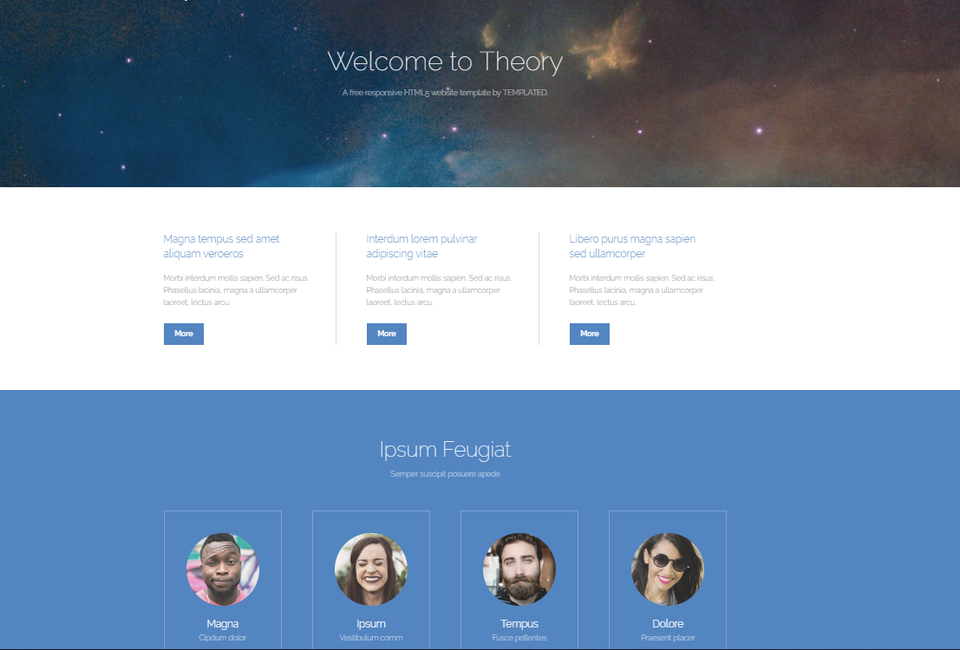

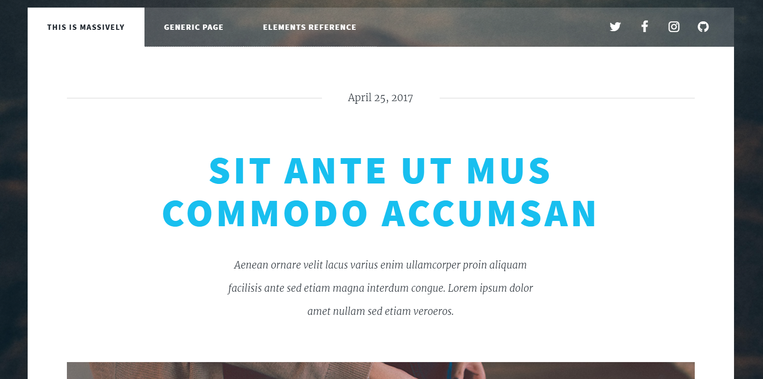

3-5 colors: screenshot from Adobe Color to show your planned color palette:

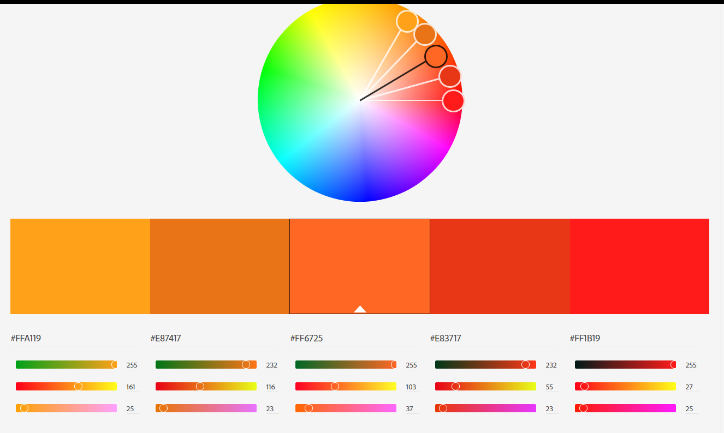

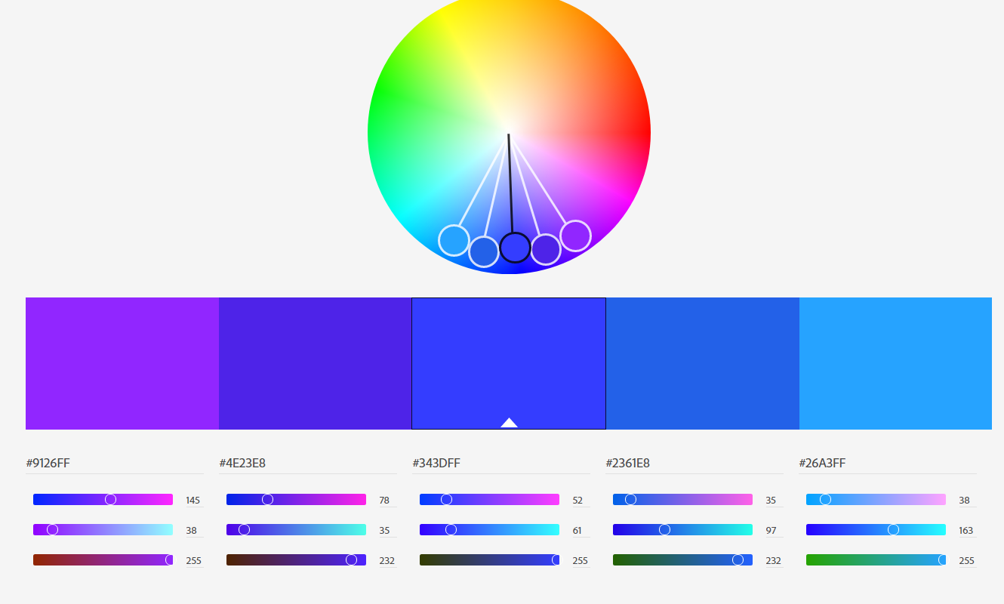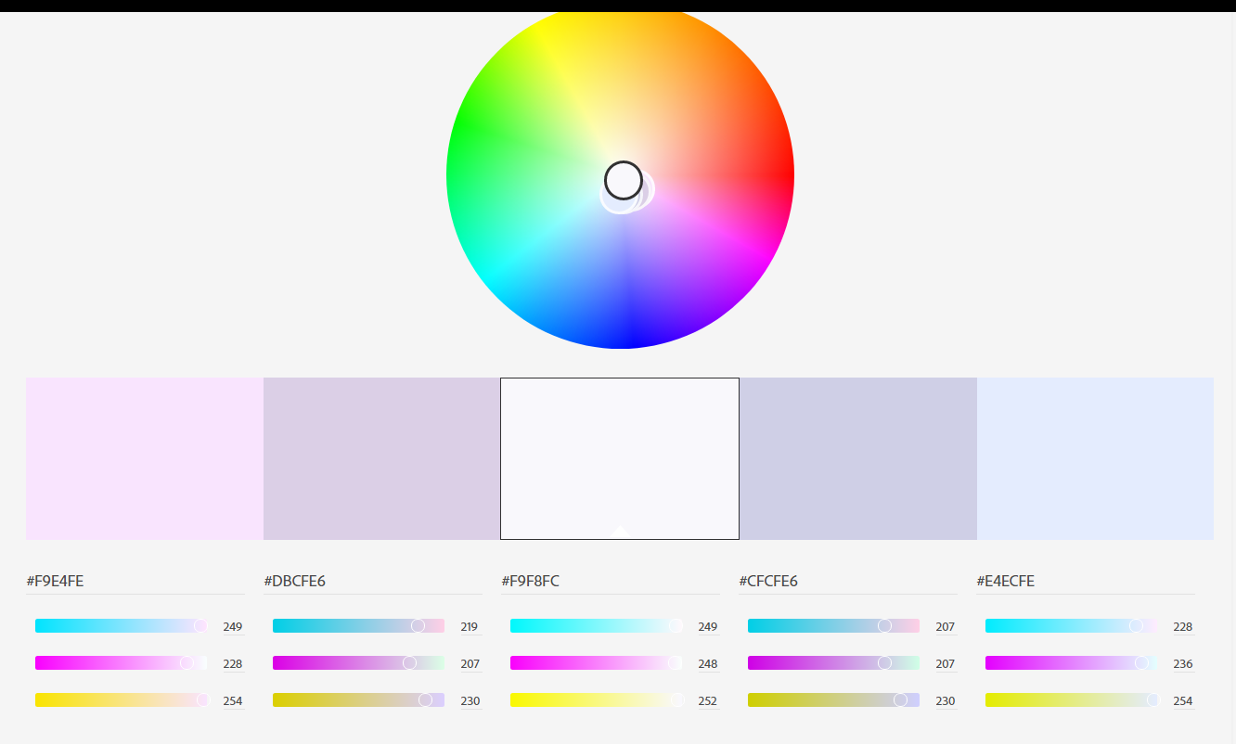

Use Balsamiq to create a simple sketch of the layout for your site to communicate the idea: